QB Analysis and Monthly Review
If you have QB, what do you do with the data every month? Do you print profit and loss and balance sheets? If you do, what do you do with them?
For $200 per month, we will download automatically financial data from your QB online or desktop and then send you a detailed 14-page report. Upon receipt, we schedule a Zoom conference call to review your data monthly and tell you what you need to do to move your company closer to the top 10% in your industry.
A sample partial metrics page is provided on the next page to show you what we measure. Many accountants charge over $1000 per month for this service, but we are industry consultants who provide the report you need.
Sign up today for this service and cancel anytime!!!
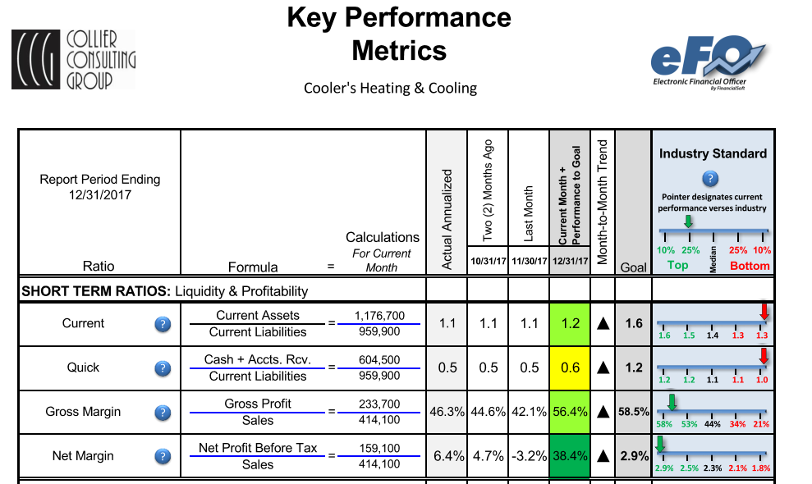
Order your plan today. Click on the link below--------
Plans & Pricing | Collier Consulting Group (collier-consulting.com)

